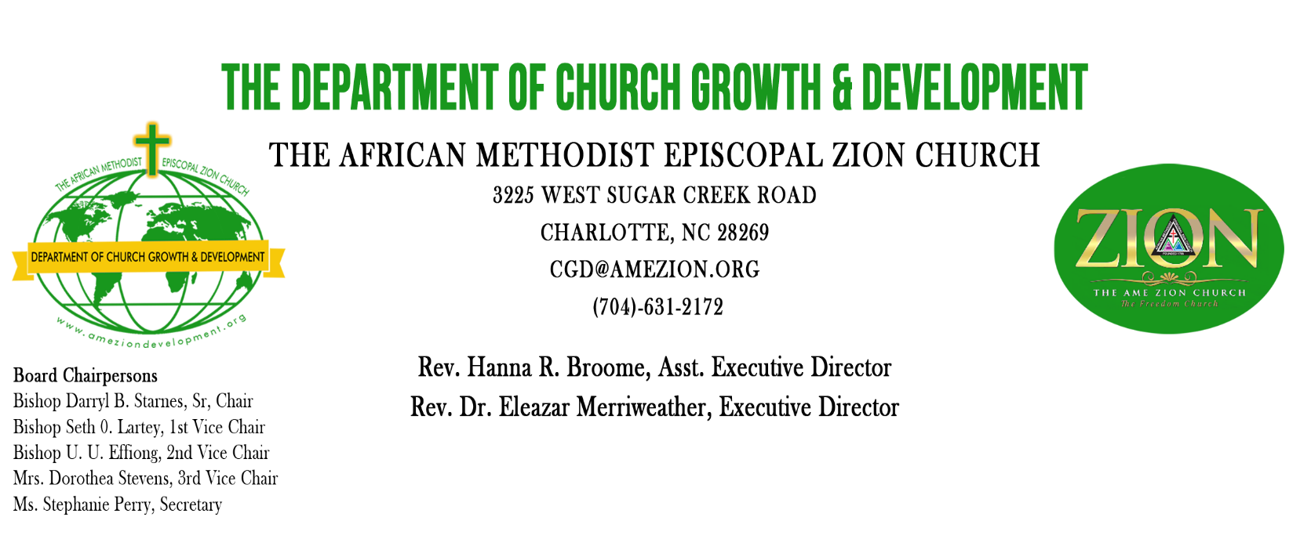
Decision Day 2022

The Book of Discipline of the African Methodist Episcopal Zion Church directs that every Sunday Church School shall emphasize "Decision Day" annually. It further directs that each Sunday Church School should undertake an evangelistic quota for active membership.”
The Annual Decision Day Observance is generally held the fourth Sunday in October. However, it may be observed any time in October or even in November if it is best convenient for the local church. During the harvest season, the constituents of the A.M.E. Zion Church pause to celebrate the harvest of souls (conversions, new members, re-dedications, etc.) gathered during the previous 12 months, as well as those entering the ministry or any form of Christian service. Forms are provided to assist churches in the reporting process.
Also, the Decision Day Observance has been an opportunity for local churches to share financial gifts in support of the Bureau of Church Growth and Development. Whereas financial gifts are appreciated, needed, and welcomed throughout the year, the Department is placing its greatest emphasis upon making decisions for Christ!
Our Connectional Quadrennial Theme is: "The Freedom Church - A Movement Empowered by Holy Spirit: Strengthening our Fellowship, Serving our Flock, Sharing our Faith, and Securing our Future." Our focus theme for this year is, "Sharing our Faith.” "Sharing our Faith” is the primary mission of the Church. “Sharing our Faith” is the process by which the church is intentional in proclaiming the Good News of God and discipling all believers in order to bring them to spiritual maturity so they too can be sent out to save even more souls. Bishop Eric L. Leake said it this way, “Bring them in, grow them up, look them over, and send them out.”
The continuous moral decay and spiritual decline of our nation demand that the church vigorously engage in “Sharing our Faith” which is the only remedy save souls and change the dangerous course of our nation.
In His Service,

Eleazar Merriweather
Rev. Dr. Eleazar Merriweather, Executive Director
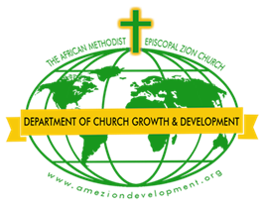
The Department of Church Growth & Development
African Methodist Episcopal Zion Church
DECISION DAY OBSERVANCE 2022
Report Form

Church _________________________________ Address____________________________________
City _________ State _________________Zip _______ Phone _______________________________
Pastor in Charge _____________________Phone ___________________ Email address: _____________
Presiding Elder _____________________ P.E. District______________________
Church Director of Evangelism _____________________ Email ________________ Cell # ___________
District Director of Evangelism _____________________ Email ________________ Cell # ___________
Presiding Bishop__________________ Annual Conference____________________
Episcopal District___________________________________________________________________________
Date of Event(s): __________________________________________________________________________
Description________________________________________________________________________________________________________________________________________________________________________________________

Report of Decisions

Type of Decisions Made | During Decision Day Observance | During the Year  November 2021-October 2022
Number of Conversions
Number of Rededications
New Members Added
Number Called to Preach
Number of Special Events

Financial Gift to the Department of Church Growth & Development $ ___________

Make Checks Payable to: Church Growth & Development
Zelle to: CGD@amezion.org
Mail to: Church Growth & Development
3225 West Sugar Creek Road
Charlotte, NC 28269
Telephone: (704) 631-2131 or (704) 631-2172, Fax: (704) 688-2547
Email: CGD@amezion.org
Website:www.ameziondevelopment.org
Spiritual Emphasis Week
January 8-14, 2023

A Week of Prayer, Praise & Proclamation”

The Department of CHURCH GROWTH & DEVELOPMENT
The African Methodist Episcopal Zion Church
Rev. Hanna R. Broome, Asst. Director
Rev. Dr. Eleazar Merriweather, Executive Director

Spiritual Emphasis Week offers an opportunity for each local church to begin the year on a high spiritual note. The entire membership should be encouraged to participate as the church gathers Sunday through Friday for Prayer, Praise, and Proclamation of the Word. This annual event should climax with the clergy and laity of the Presiding Elder District coming together for a special District service. The suggested theme and daily sub-themes for Spiritual Emphasis Week 2023 are as follows:
Quadrennial Theme: The Freedom Church – Movement Empowered by the Holy Spirit: strengthening our Fellowship, Serving our Flock, Sharing our Faith, and Securing our Future.
Scripture: “Then the eleven disciples went to Galilee, to the mountain where Jesus had told them to go. When they saw him, they worshiped him; but some doubted. Then Jesus came to them and said, "All authority in heaven and on earth has been given to me. “Therefore go and make disciples of all nations, baptizing them in the name of the Father and of the Son and of the Holy Spirit, and teaching them to obey everything I have commanded you. And surely I am with you always, to the very end of the age” (Matthew 28:16-20, NIV).
Proposition: Sharing our Faith is the primary responsibility Christ commissioned to the Church and is accomplished only by being obedient to His Mandate.

Day Date Topic Scripture
Sunday January 8 Sharing our Faith by going to the appointed place to meet Christ Matthew 28:16
Monday January 9 Sharing our Faith by giving genuine adoration to Christ Matthew 28:17
Tuesday January 10 Sharing our Faith by adhering to the authority of Christ Matthew 28:18
Wednesday January 11 Sharing our Faith by going where Christ sends us Matthew 28:19
Thursday January 12 Sharing our Faith by having a global perspective of Christ’s Mission Matthew 28:19
Friday January 13 Sharing our Faith by Teaching what Christ taught Matthew 28:20
Saturday January 14 Sharing our Faith by having the assurance of the Christ’s Presence Matthew 28:20

