Credential Of Election

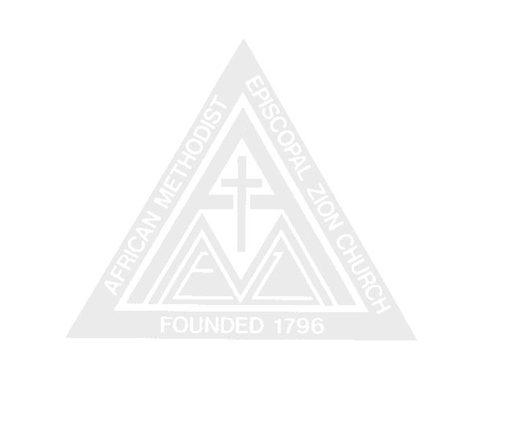

for annual conference delegate

THIS IS TO CERTIFY THAT
has been duly elected Delegate to the
Annual Conference of the AFRICAN METHODIST EPISCOPAL ZION CHURCH which meets
at , 2008.
Said elegate is to represent
A.M.E. Zion Church of

Done at on , 2008.

, Secretary

, Chairman (Presiding Elder)
or
, Pastor

