Credential Of Election

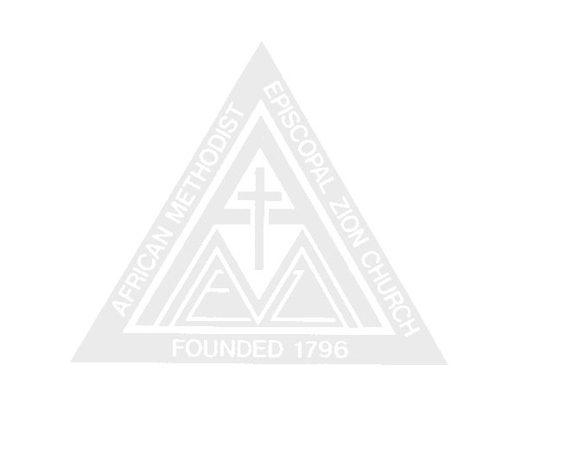

for District conference delegate

THIS IS TO CERTIFY THAT
has been duly elected Delegate to the Boston
District Conference of the New England AFRICAN METHODIST EPISCOPAL ZION CHURCH which meets at Evans Memorial A.M.E. ZION CHURCH, MEMPHIS, TN NOVEMBER 9-13, 2011
Said delegate is to represent (Church Name) A.M.E. Zion Church

Done at on , 2011.

, Secretary

, Chairman (Presiding Elder)
or
, Pastor

