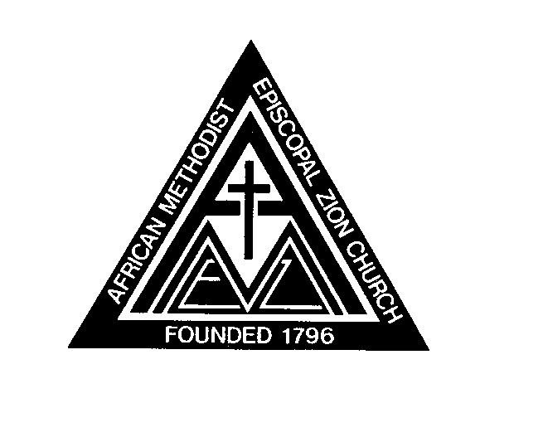
AFRICAN METHODIST EPISCOPAL ZION CHURCH

QUARTERLYREPORT

Local Preacher’s Quarterly Conference Report

A Supernumerary Preacher is one who has been left without an appointment by the bishop. He or she still remains a member of, and is expected to attend the annual conference, but shall be subject to, during the year, and enjoy the privileges of the quarterly conference where he or she resides, and shall report to the district conference.

Durham Memorial A.M.E Zion Church Reverend Kevin D. Coakley Charge
Buffalo District Western New York Annual Conference

For the period beginning _______________and ending ____________________

- Number of Sermons preached.

- Number of Marriages solemnized.

- Number of Baptisms performed.

- Other labors performed

Conference and District Affiliations:

Personal Studies/ Current Reading Materials

.

Date |  | (Print)
 |  | (Local Preacher’s Signature)
 |  | Pastor, Rev. Kevin D. Coakley

